**BITS PILANI, K.K. BIRLA GOA CAMPUS**

SEMESTER II- 2024-25

**Assignment-II**

**Course No.**: ECON F215

**Course Title**: Computational Economics

**Course Instructor In-Charge**: Dr. Sandip Sarkar

**Submission deadline**: 27/04/2025

**Date of Presentation**: 28/04/2025



**Suvid Singhal**

**2023B3A70972P**

**The Legacy of Colonial Land Tenure Systems in India:**

**A Replication and Analysis of Banerjee & Iyer (2005)**

**Introduction**

**Research Question:** Do historical institutions have a persistent impact on modern economic outcomes?

The role of historical institutions in shaping modern economic outcomes has been a growing field of inquiry in economics. Banerjee and Iyer (2005) provide a big contribution by analysing how different land revenue systems introduced by the British colonial administration in India influenced long-term agricultural development.

This report aims to replicate and analyse the instrumental variable (IV) results from Table 4 of Banerjee and Iyer (2005) using R, verifying the impact of land tenure systems on agricultural investments and productivity.

**Historical Background**

British colonial rule in India introduced three primary land revenue systems:

* **Zamindari system** (landlord-based): Revenue was collected through landlords who had ownership rights over the land.
* **Ryotwari system** (non-landlord-based): Revenue was collected directly from cultivators.
* **Mahalwari system** (village-based): Revenue was assessed at the village community level.

The choice of system was not based purely on geography or agricultural potential but was heavily influenced by the timing of British conquest. Areas brought under British rule between 1820–1856 were more likely to receive non-landlord systems due to ideological shifts in colonial policy.

Banerjee and Iyer hypothesize that these historical differences persist, with non-landlord regions achieving better long-term economic performance, particularly in agriculture.

**Data Description**

The dataset used in this study comes from Banerjee and Iyer’s replication files, originally shared in Stata format via openICPSR.

Link to the Dataset: <https://www.openicpsr.org/openicpsr/project/116059/version/V1/view>

Key variables used:

* Dependent variables: Agricultural outcomes such as irrigation share (irr_g), fertilizer use, HYV (High Yield Variety) adoption, and crop yields.
* Main explanatory variable: p_nland — proportion of land under non-landlord systems.
* Instrumental variable: britdum — dummy equal to 1 if the district came under British control between 1820 and 1856.
* Controls: Rainfall (totrain), altitude (alt), latitude (lat), coastal dummy (coastal).

Data transformations included computing the area under HYV for other cereals (i.e., crops excluding rice and wheat). For that, we just subtracted area of rice and wheat from the total irrigated area.

**Regression and Causal Inference**

**OLS Estimation**

Initially, an OLS regression was performed, regressing various agricultural outcomes on the non-landlord proportion (p_nland) while controlling for geographic factors. However, simple OLS estimates may be biased due to potential endogeneity: British administrators may have chosen different land systems based on unobservable district characteristics.

**Addressing Endogeneity: Instrumental Variables (IV)**

**To correct for endogeneity:**

An IV approach was implemented, using britdum as an instrument for p_nland.

The first stage regresses p_nland on britdum and geographic controls.

The second stage uses the predicted p_nland values to estimate effects on agricultural outcomes

Instrument validity assumptions:

* **Relevance:** Conquest timing is strongly correlated with the likelihood of a non-landlord system (confirmed via first-stage results).
* **Exclusion:** Conquest timing affects current agricultural productivity only through its impact on land tenure systems, not through other channels.

**Results**

Below are the results replicating Table 4 from Banerjee and Iyer (2005):

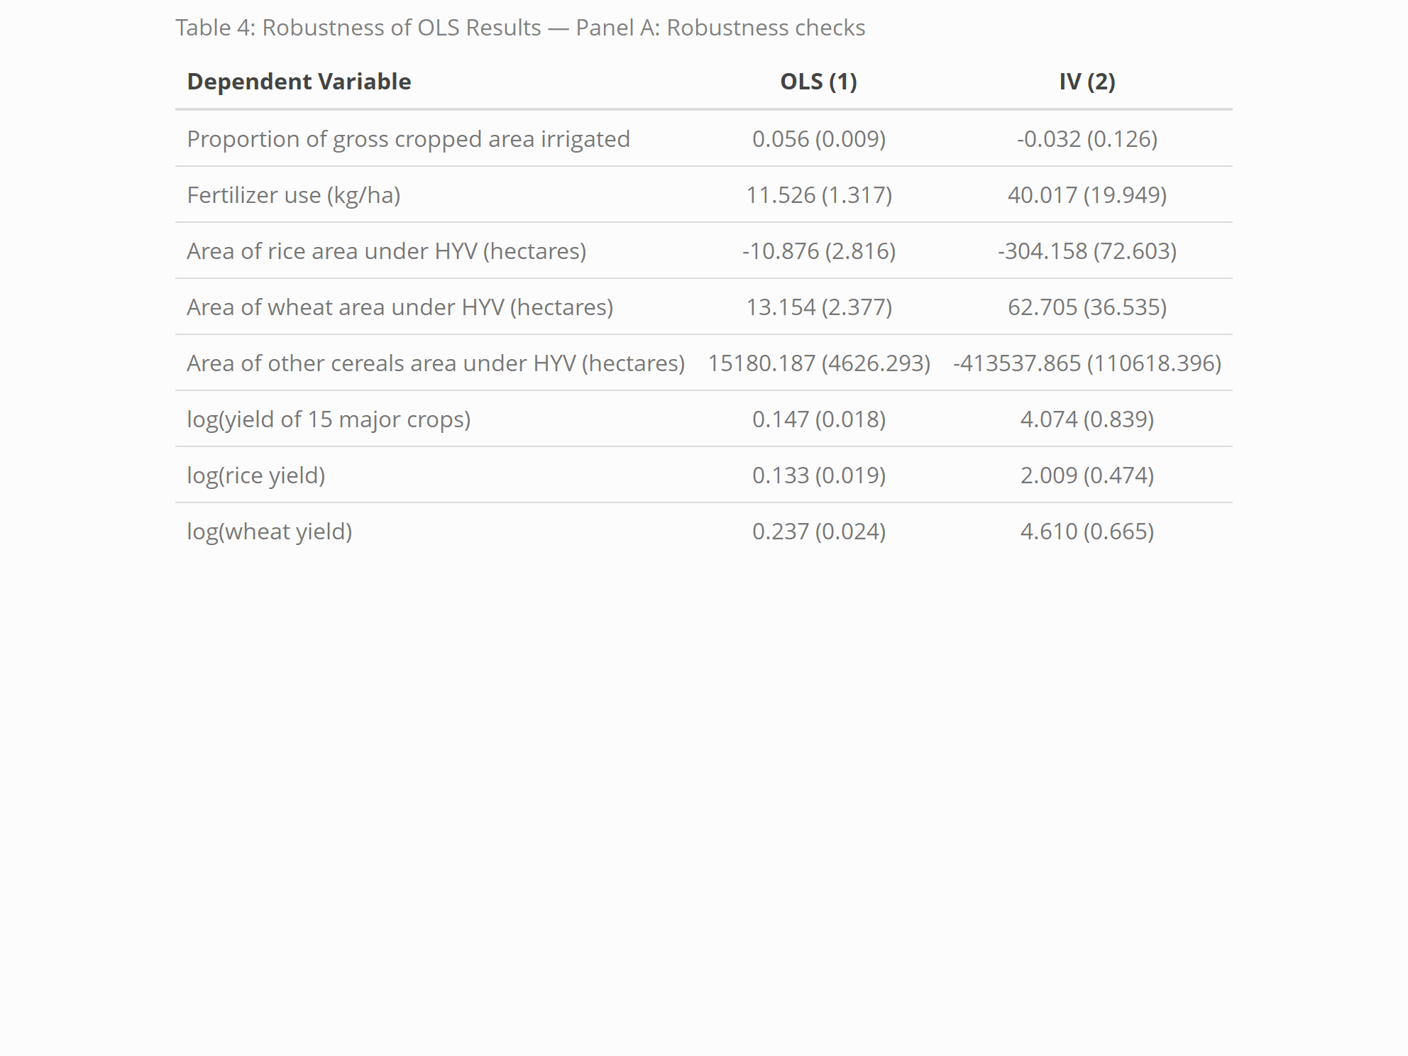

**Notes**: Standard errors in parentheses.

OLS regressions control for latitude, altitude, and rainfall. IV regressions use britdum as an instrument for p_nland.

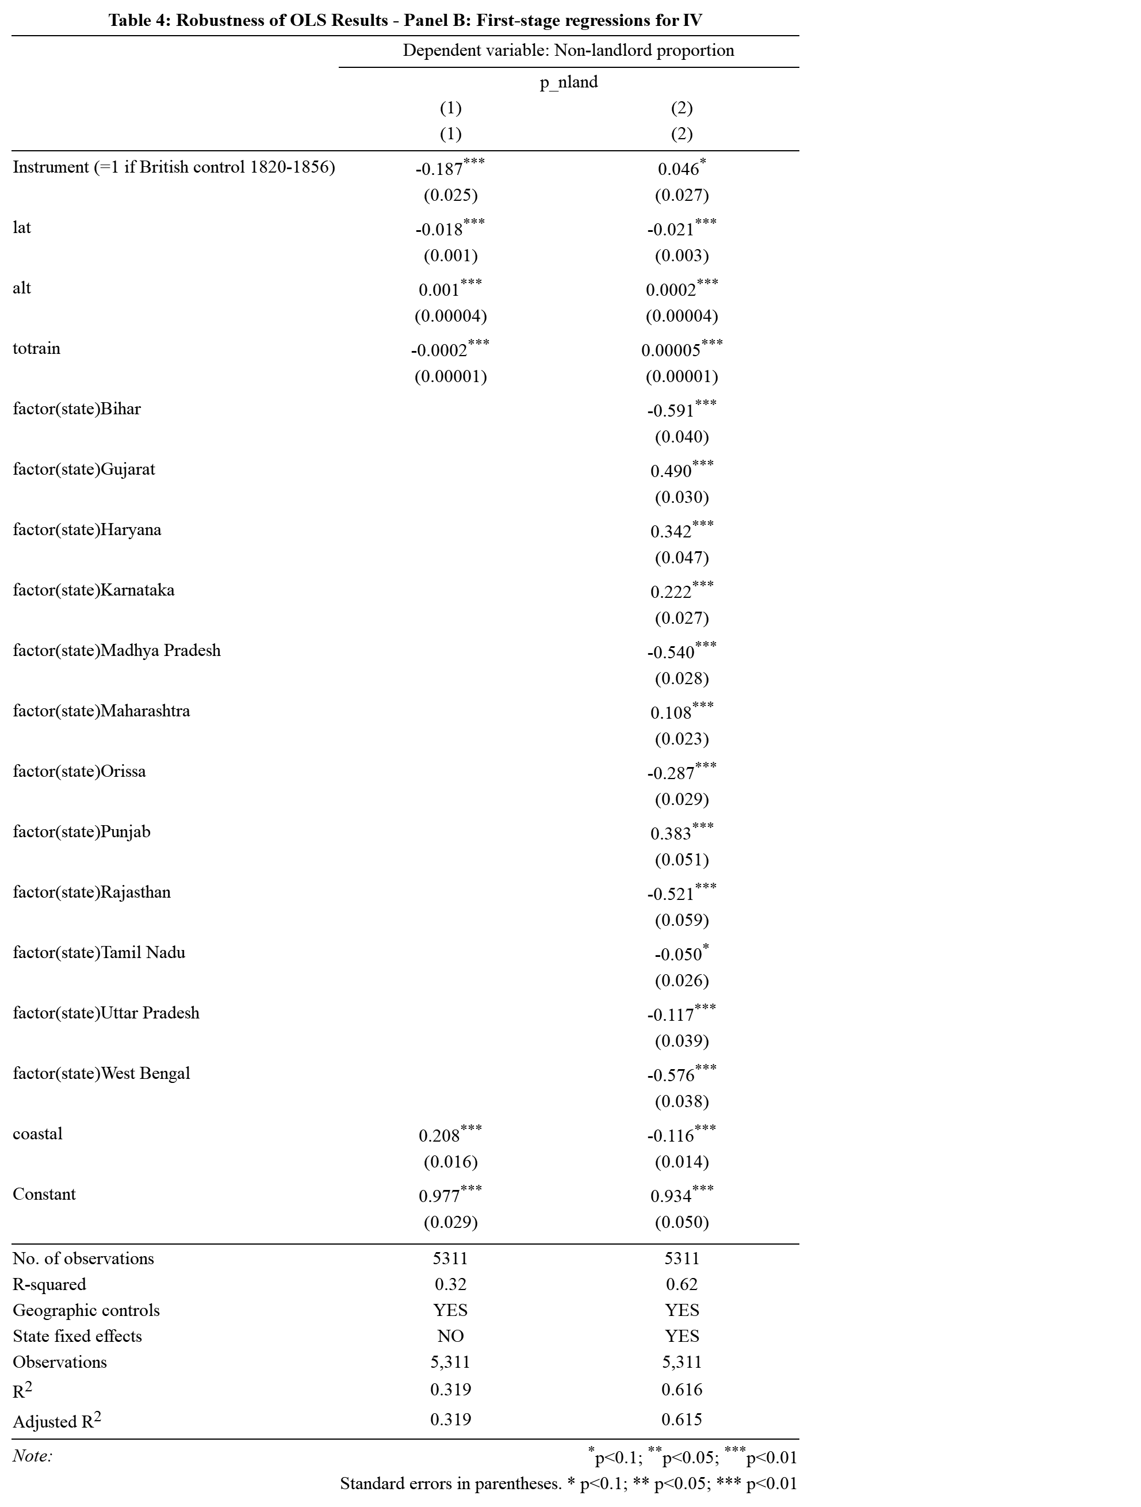

**Notes**: Controls include rainfall, altitude, latitude, and coastal dummy. State fixed effects included in (2).

**Important Observation:** Without state fixed effects, the relationship between conquest timing and non-landlord share appears negative, likely due to confounding by differences across states. Some states may have had earlier conquests and landlord systems, others later and non-landlord systems. When we include state fixed effects, we remove these cross-state biases. The positive coefficient after controlling for state confirms that, within states, conquest between 1820 and 1856 led to a higher share of non-landlord systems, as expected based on the historical institutional change.

The negative coefficient and difference in results for the instrument can also be attributed to these missing dependent variables in our version of the dataset:

* Date of British land revenue control (continuous)
* Date of British land revenue control squared (continuous)

**Interpretations**

The results strongly support the hypothesis that non-landlord systems had a positive long-term impact on agricultural investments and productivity:

* Higher fertilizer usage and HYV adoption rates are observed in non-landlord areas.
* Crop yields are significantly higher, even after correcting for endogeneity through IV.

Key interpretation points:

* IV estimates are generally larger in magnitude than OLS, implying that simple OLS likely underestimates the true causal effect.
* For the "other cereals area under HYV," large coefficients arise due to the dependent variable being measured in absolute area units (hectares)

In the first-stage regressions, the conquest dummy (britdum) is strongly correlated with the non-landlord share, confirming instrument relevance.

While interpreting the results, several alternative explanations must be considered and addressed:

* **Selection into Land Systems:**

British administrators did not assign landlord systems based on agricultural productivity. Instead, ideological shifts around 1820 determined whether newly conquered districts received zamindari settlements.

* **Endogeneity of Conquest Timing:**

The order of British conquest was shaped by political resistance and military strategy, not by economic factors like land fertility or wealth.

* **Contemporary Policy Differences:**

Inclusion of geographic controls and state fixed effects demonstrates that modern policy variations are unlikely to explain the observed differences.

* **Other Historical Institutions:**

The focus on British-administered districts minimizes confounding from differing local institutions.

* **Direct Effects of Early British Rule:**

Historical evidence suggests that early British control was primarily extractive and is unlikely to have independently fostered long-term agricultural development.

**Conclusion**

This replication confirms that colonial institutions have deep and persistent impacts on modern economic outcomes.

Landlord-based systems hindered long-run agricultural development, while non-landlord systems fostered greater investments in irrigation, technology adoption, and crop yields.

These findings align with broader theories emphasizing the critical role of historical institutions in shaping current prosperity.

Link to paper: <https://www.jstor.org/stable/pdf/4132711>

Link to R code: <https://pastebin.com/WDzppdZx>